**Procedure Installation of Mathematica 8 in Microsoft Windows**

Mathematica 8 software are available on CC ftp site. And run the setup file Mathematica_8.04_Win.

1. Click on the “Next” button.

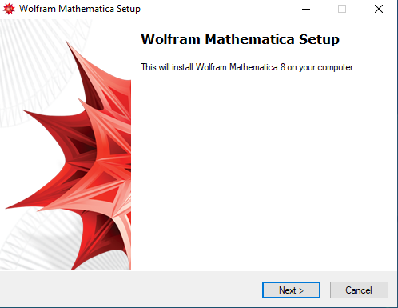

1. Click on the “Next” button.

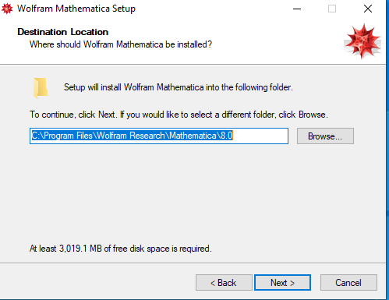

1. Select all options as shown below and click on the “Next” button.

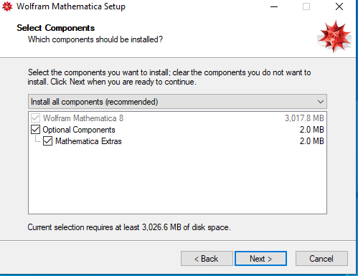

1. Click on the “Next” Button.

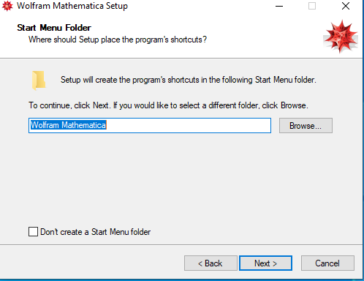

1. Click on the “Next” Button.

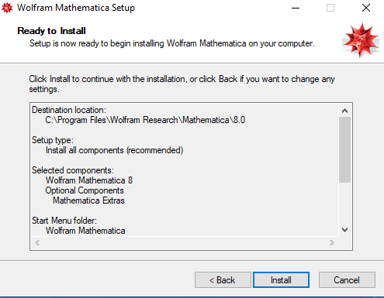

1. Wait a few minute after then Installation complete.

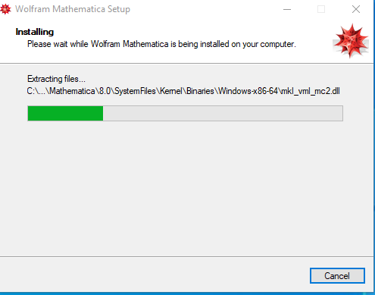

1. Now open the “Mathematica 8” and wait for initialization. “after a few second “Wolfram product Activation” window occurs. Choose “Other Ways to activate” to activate Mathematica8 Licence.

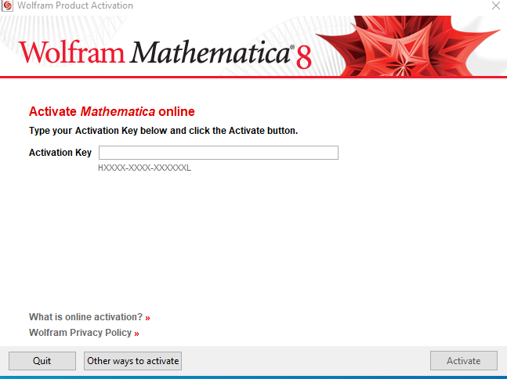

1. Click on “Connect to a network licence server” option.

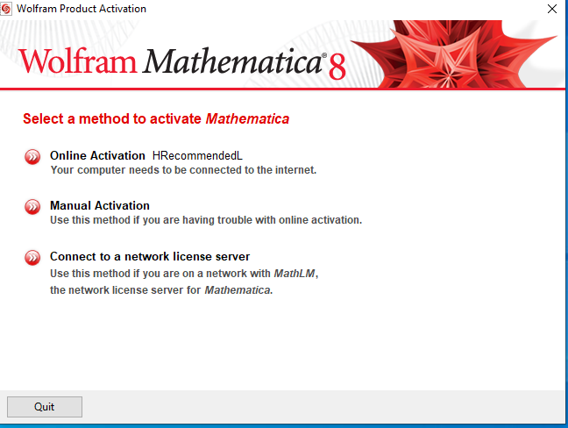

1. Enter the “Network License Server” IP Add in the Server name box (License server is 172.31.1.4 or 172.31.1.5 or akash2.cc.iitk.ac.in).and click on “Activate”.

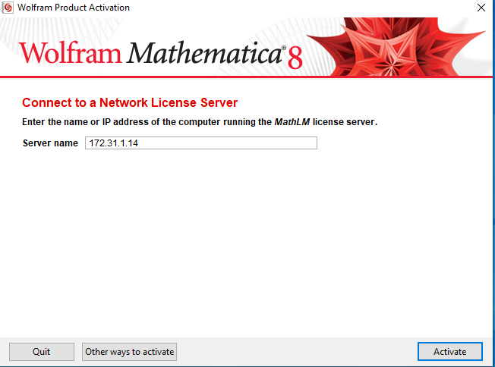

1. Check the “I accept the terms of this agreement” and Click on “OK” button.

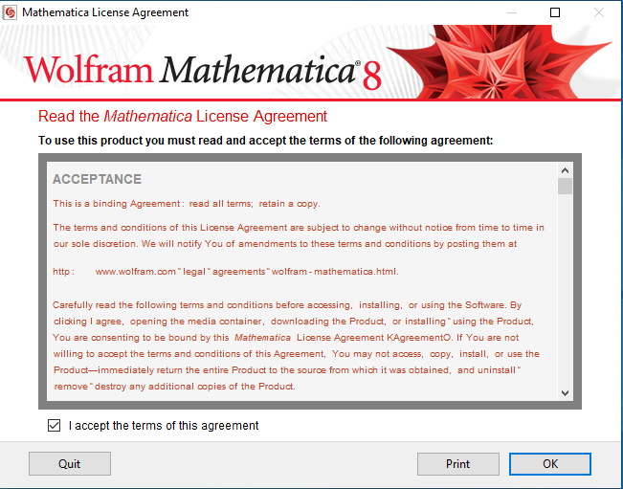

1. The Preview of Mathematica 8 as shown below.

